# Tool Selection Review:

## Front End:

Front End refers to what we see on the screen such as the User Interface. This will be made by using two major components being

### HTML:

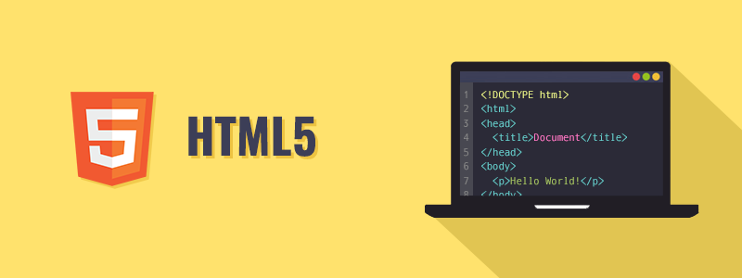

The Hypertext Markup Language, or HTML is the standard markup language for documents designed to be displayed in a web browser.

### CSS:

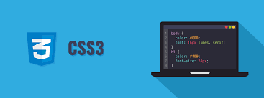

Cascading Style Sheets is a style sheet language used for describing the presentation of a document written in a markup language such as HTML.

## Back End:

Backend majorly consists of the database that stores all the information for a specific application. For the purpose of database, we will be using only a single database being

### MySQL:

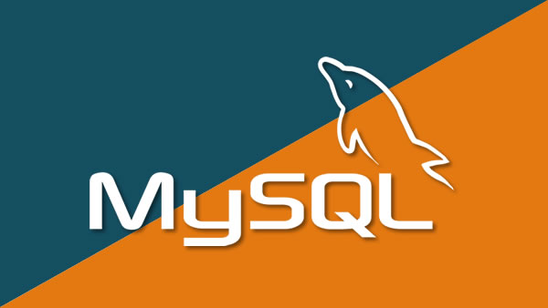

MySQL is an open-source relational database management system.

## Functionality:

This is the middle layer that joins the front end with the back end and performs most of the actions for the application. For the purposing of adding such functionalities we require scripting languages that we have selected two different for the application. A combination of both will be used for the purpose of project.

## PHP:

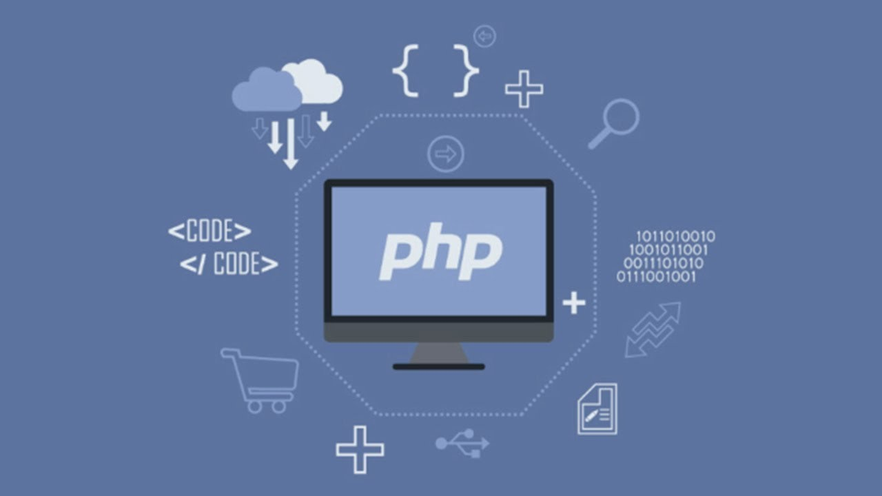

PHP is a general-purpose scripting language especially suited to web development.

## JavaScript:

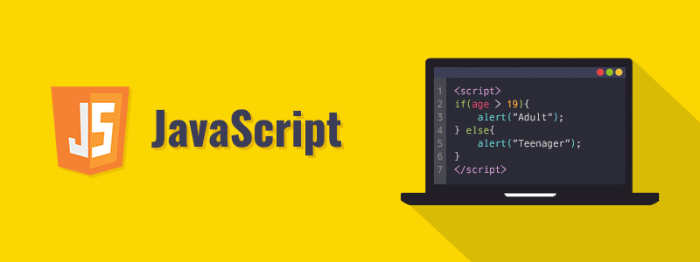

JavaScript, often abbreviated as JS, is a programming language that conforms to the ECMAScript specification. JavaScript is high-level, often just-in-time compiled, and multi-paradigm.